**EXCEL TEMPLATE**



*CREATE TWO SHEET

*SHEET1 -> IS ACTUAL PAGE WE WORK OUR TEMPLATE.

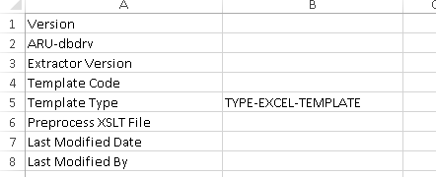

*XDO_METADATA->PASTE THE PREDEFINED COLUMN(THIS SHEET IS MUST).

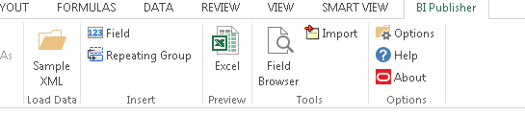

*LOAD SAMPLE DATA.

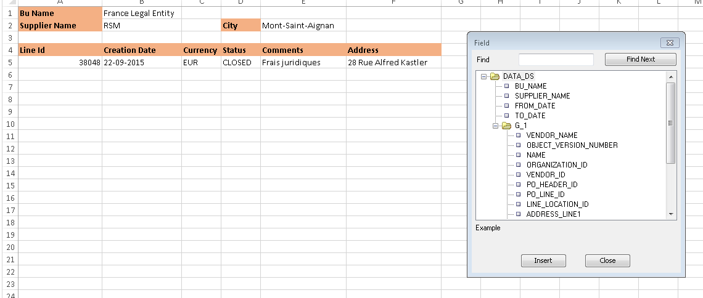

*INSERT COLUMNS AS WE REQUIRED IN YOUR TABLE USING FIELD(INSERT).

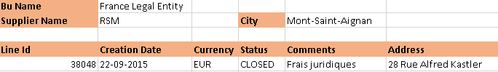

*SELECT UPTO THIS AND CLICK -> REPEATING GROUP -> GROUP BY->NAME(BU NAME).

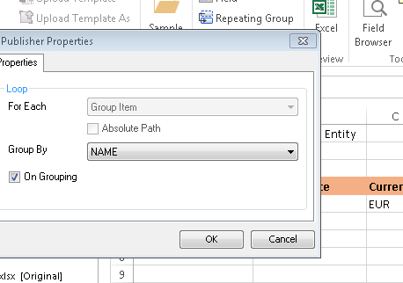

*CLICK OK.

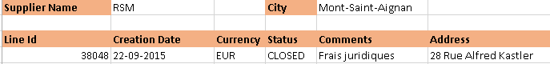

*SELECT UPTO THIS.

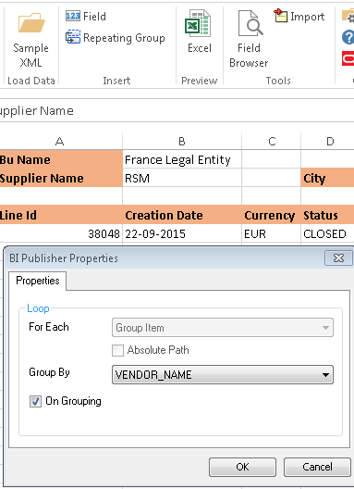

*REPEATING GROUP -> GROUP BY -> VENDOR NAME.



*SELECT SINGLE ROW ALONE AND GIVE REPEATING GROUP(DON’T GIVE ANY GROUP)->OK.

*SAVE FILE -> CLICK ->EXCEL.

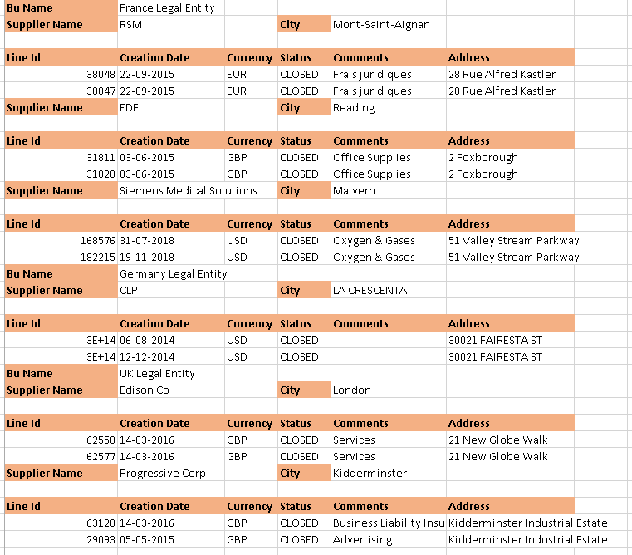

*CLICK -> EXCEL ->FINAL OUTPUT.

*FOR SEPERATE SHEET ACCORDING TO BU -> ORACLE INSTENCE ->UPLOAD->RTF FILE -> EXPORT -> EXCEL.XLS.